Order of Experiment in clinical trial:

Four time periods, in the following order. The patient is in very different states in each of these periods:

1. Fasting (from beginning of experiment until before first insulin) - Patient has been fasting for many hours. Blood sugar levels may appear normal, but patient's organs may be low on energy.

2. First Insulin (from first insulin until before Ensure) - Insulin dose causes glucose to be absorbed from the blood into the cells, which can cause low blood sugar levels =hypoglycemia

3. Ensure (from Ensure until before second insulin) - Ensure dose causes blood glucose levels to rise = hyperglycemia

4. Second Insulin (from second insulin till end of experiment) - The body's response to insulin here (hyperglycemia) may be different than the body's response to the first insulin (administered under fasting conditions).

The “average” responses that were observed are as follows:

the "cleanest insulin signal happens with the first insulin injections at the initial experimental phase in order to induce a low (~70). When i am observing the real time sensor readings, i am looking at a Fast fourier transformation which has an amplitude v Hz graph. In my observations, baseline (before insulin shows a peak between 0-1 Hz ie the base of the peak spans the distance between 0-1 Hz, insulin administration increases the amplitude and extends the base of the first peak to extend closer to 1-1+Hz but i also see additional activity from two to 7 Hz.(I will send you pics). so insulin has a higher amplitude peak between 0-1Hz and smaller peaks between 2-7-8Hz. Ensure shows a narrow peak amplitude spanning 0-0.5 Hz very close to the O Hz line. When you add insulin to the subject at the hyperglycemic state, I observe a narrow peak between 0-0.5Hz and then some additional activity as 2-7Hz that has a much smaller amplitude than the initial insulin (at times) and then will revert to the "hyperglycemic" signal (peak at 0-0.5Hz)

**Baseline** (ie before first insulin): before insulin shows a peak between 0-1 Hz ie the base of the peak spans the distance between 0-1 Hz, (images are from different patients)

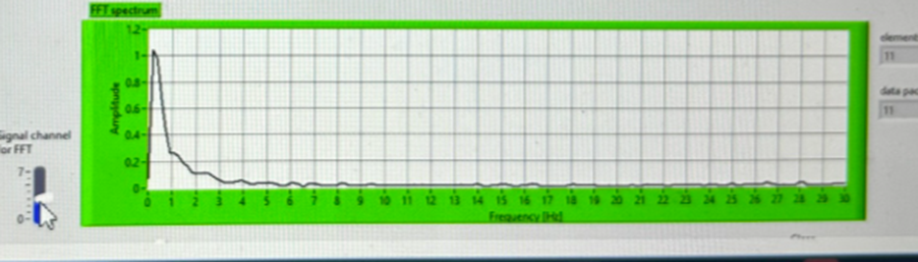

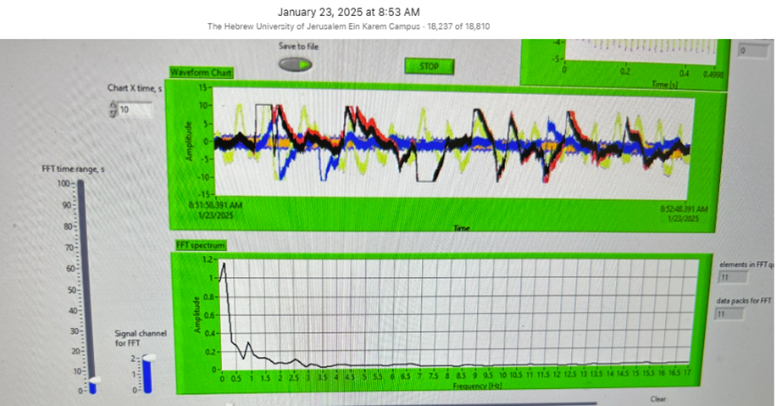

**First Insulin**: insulin administration increases the amplitude and extends the base of the first peak to extend closer to 1-1+Hz but i also see additional activity from two to 7 Hz. Insulin administration results in an elevation in EMF activity and in hypoglycemia.

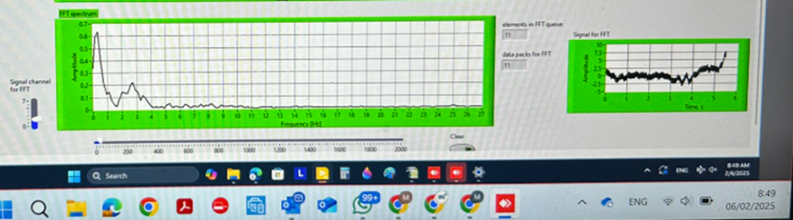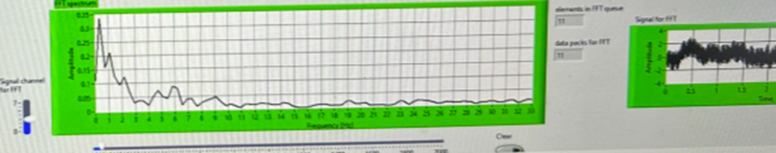

**Ensure (high sugar drink**): Ensure shows a narrow peak amplitude spanning 0-0.5 Hz very close to the O Hz line

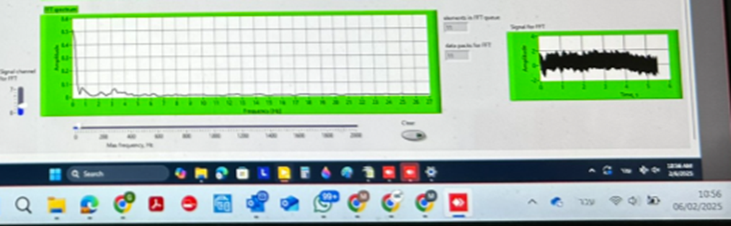

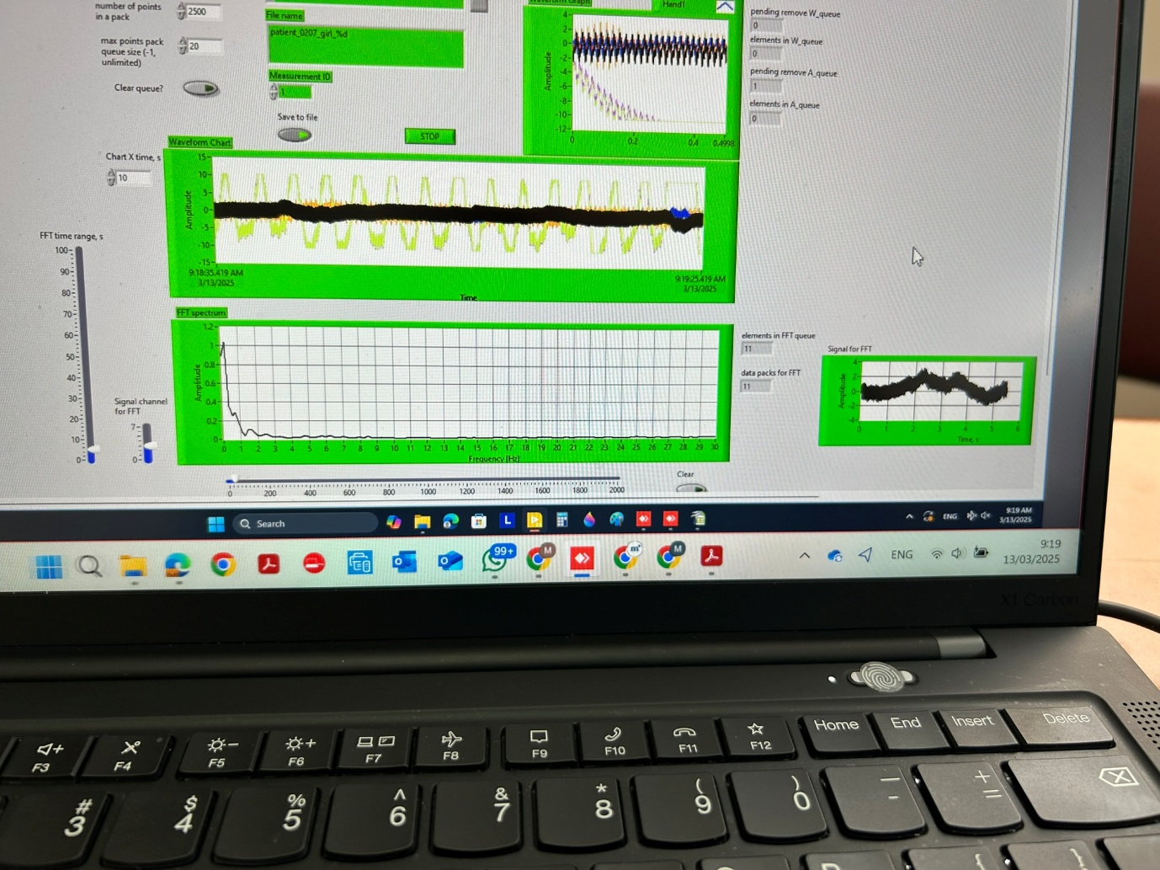

**Second Insulin**: When you add insulin to the subject at the hyperglycemic state, I observe a narrow peak between 0-0.5Hz and then some additional activity as 2-7Hz that has a much smaller amplitude than the initial insulin (at times) and then will revert to the "hyperglycemic" signal (peak at 0-0.5Hz)

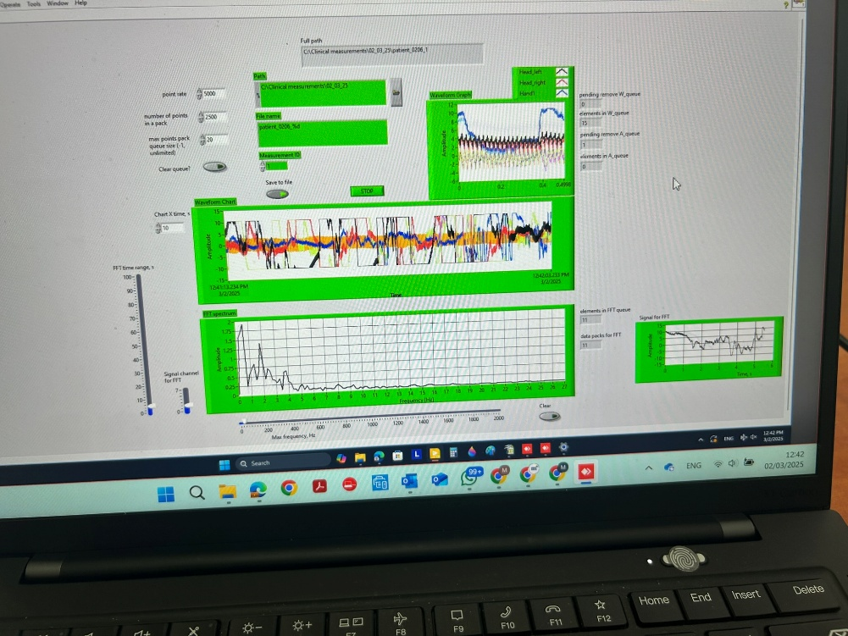

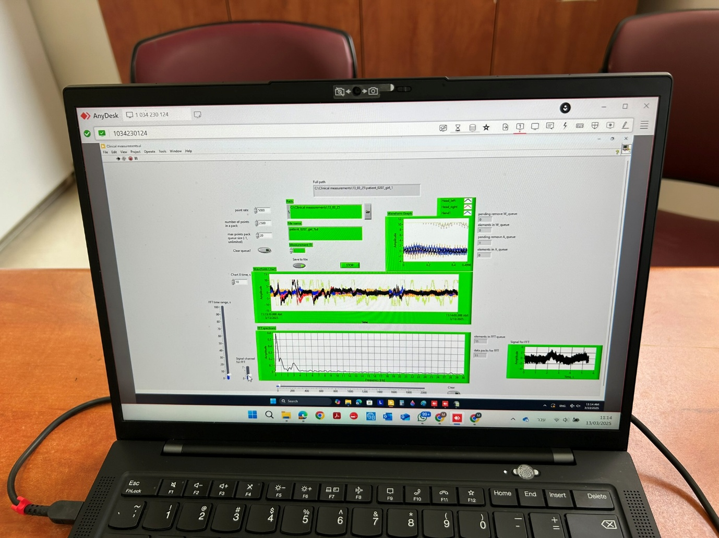

**Different Insulin in same patient has different “fingerprint”**

Novorapid



Lyumjev

